Contents

1.0 CHAPTER ONE: INTRODUCTION 2

1.0.0 Introduction 2

1.1 Background to the study 2

1.2 Problem statement 3

1.3 Purpose of the study 3

1.4 Objectives of study 3

1.4.1 General objective of study 3

1.4.2 Specific Objectives of study 4

1.5 Research Questions 4

1.6 Significance and justification of the study 5

1.7 Limitation of Study 5

1.8 Methodology 6

2.0 CHAPTER TWO: LITERATURE REVIEW 7

2.1 Introduction 7

2.2 Theoretical framework 7

2.3 Previous studies 8

2.3.1 FAO promoting health diet 8

2.3.2 Impact of a new web-based app (e-balance) in promoting healthy lifestyle 9

2.4 Research gaps 9

2.5 Research variables arising from literature review 9

2.6 Conclusion 10

3.0 CHAPTER THREE: METHODOLOGY AND DESIGN 11

3.1 Introduction 11

3.2 Research Philosophy and approach 11

3.3 Research design 12

REFEENCE 12

# **1.0 CHAPTER ONE: INTRODUCTION**

## 1.0.0 Introduction

As a developing country, Zambia is faced with many challenges in ensuring the health and well-being of its citizens. One of these challenges is the poor eating habits of many Zambians, who often struggle to access or afford a varied and nutritious diet. Studies have shown that many Zambians consume diets that are high in processed foods and low in fruits and vegetables, leading to a range of health problems including obesity, diabetes, and heart disease.

To address this problem, this dissertation proposes the development of a web application that uses a random generation algorithm to help users create a balanced diet for a week. The application will take into account the user's dietary preferences, allergies and other restrictions and generate a diet plan that is nutritionally balanced and easy to follow. The goal of this project is to improve the health and well-being of Zambians by providing them with an accessible and convenient tool for following a healthy diet.

Technology is an ideal way of solving this problem as it allows for a high degree of scalability, accessibility and personalization. The application can be accessed by a large number of people from any location with an internet connection, and the random generation algorithm allows for the creation of personalized diet plans that are tailored to individual preferences and requirements. Additionally, technology allows for the collection of data on user engagement and satisfaction, which can be used to improve the application over time.

## 1.1 Background to the study

Zambia has taken several steps to promote healthy eating habits and address the issue of poor nutrition among its population, with a focus on high-risk groups such as diabetics and children.

1. The National Food and Nutrition Commission (NFNC) is responsible for coordinating and implementing nutrition policies and programs, with a focus on addressing the nutrition needs of vulnerable groups such as diabetics and children.
2. The Scaling Up Nutrition (SUN) Movement is a global effort to improve nutrition outcomes, and Zambia is a member of this movement. Through its membership, Zambia has access to resources and technical assistance to support its nutrition programs and address specific issues such as diabetes and childhood obesity.
3. The Ministry of Agriculture and Livestock promotes the production of nutritious food in the country, with a focus on smallholder farmers and promoting sustainable agriculture.
4. Community-based nutrition programs run by NGOs and CBOs also focus on promoting healthy eating habits and addressing specific issues such as diabetes, through nutrition education and awareness-raising campaigns.

## 1.2 Problem statement

Despite efforts made by the government and other organizations to promote healthy eating habits and address poor nutrition in Zambia, the country continues to face significant challenges in this area, particularly among high-risk groups such as diabetics and children. The dissertation aims to investigate the root causes of these challenges and propose a solution in the form of a web-based application that uses a random generation algorithm to help users create balanced diets for a week. The application could be a solution to help people overcome the challenges of poor nutrition in Zambia and improve the health outcomes of the population.

## 1.3 Purpose of the study

To research and develop a web-based system that can help generate a balanced diet for users in Zambia, with a focus on addressing the problem of poor nutrition, particularly among high-risk groups such as diabetics and children. The system will use a random generation algorithm to create a personalized diet plan for each user based on their dietary restrictions and preferences. The study aims to investigate how this system can improve nutrition and overall health outcomes for users in Zambia, as well as identify any challenges or limitations in implementing such a system in the country. The general objective is to contribute to the improvement of the public health in Zambia.

## 1.4 Objectives of study

### 1.4.1 General objective of study

To develop a web application, code named "HealthyBites!," that helps users in Zambia generate a balanced diet for a week using a random generation algorithm, in order to address the problem of poor nutrition in the country, particularly among high-risk groups such as diabetics and children.

### 1.4.2 Specific Objectives of study

1. To understand the current state of nutrition in Zambia and the challenges faced by the population in following a healthy eating regimen.
2. To investigate the effectiveness of using technology as a solution to improve nutrition in Zambia.
3. To design and develop a user-friendly web application that generates a personalized, balanced diet for users based on their dietary restrictions and preferences.
4. To evaluate the effectiveness of the developed web application in promoting healthy eating habits and improving nutrition among users.
5. To identify any limitations or areas for improvement in the web application and suggest recommendations for future work.

## 1.5 Research Questions

1. What is the current state of nutrition in Zambia and what challenges do the people face in following a healthy diet?
2. What are the existing solutions to improve nutrition in Zambia and what is their effectiveness?
3. How can technology be used to improve nutrition in Zambia?
4. Is the use of technology an effective solution to promoting healthy eating habits and improving nutrition in Zambia?
5. How can a user-friendly web application be designed and developed to promote healthy eating habits and improve nutrition among Zambian people?
6. What are the key features and functionalities of a successful web application for promoting healthy eating habits and improving nutrition in Zambia?
7. How effective is the developed web application in promoting healthy eating habits and improving nutrition among users in Zambia?
8. What is the user feedback and experience with the web application and what is the impact of the application on their nutrition and health status?
9. What are the limitations or areas for improvement in the web application and what changes need to be made to make it more effective in promoting healthy eating habits and improving nutrition among Zambian people?
10. What are the best practices and recommendations for future work to improve the web application and enhance its impact on promoting healthy eating habits and improving nutrition in Zambia?

## 1.6 Significance and justification of the study

The significance of this study lies in the potential impact it can have on improving the nutritional status of individuals in Zambia, particularly among high-risk groups such as diabetics and children. With the increasing prevalence of diet-related health issues and the lack of accessible and user-friendly meal planning resources, there is a pressing need for a web-based meal planning application that utilizes advanced web technologies to make healthy eating more convenient and achievable. By researching and developing such a system, we aim to address this need and contribute to the overall health and well-being of the population. The justification for this study is rooted in the potential benefits it can bring to individuals and the community as a whole, as well as the potential for future research and advancements in the field of web-based health interventions

## 1.7 Limitation of Study

1. Data collection limitations: The study may face challenges in accurately collecting data on dietary habits and nutrition status of individuals in Zambia, which can affect the validity of the findings.
2. Cultural and social factors: The cultural and social norms surrounding food and eating habits in Zambia may impact the effectiveness of the web application in promoting healthy eating.
3. Technology adoption: The study may also face challenges related to technology adoption, as individuals may not be familiar with using web applications or may not have access to the technology needed to use the application.
4. Limited sample size: The study may have a limited sample size, which may affect the generalization of the results.
5. Data privacy and security: The study must consider data privacy and security concerns, as individuals may not be comfortable sharing personal information such as dietary restrictions and preferences with a web application.
6. Resource constraints: The study may face budget and resource constraints, which could impact the quality and accuracy of the results.

## 1.8 Methodology

The methodology for this study will involve a combination of quantitative and qualitative methods in order to effectively gather and analyze data within the given time frame.

1. A literature review will be conducted to gather information on current meal planning applications and the nutritional status of individuals in Zambia, particularly among high-risk groups such as diabetics and children.
2. Interviews will be conducted with a sample of healthcare professionals in Zambia to gather their perspectives on the current state of nutrition in the country and the potential impact of a web-based meal planning application.
3. prototype of the web-based meal planning application will be developed and tested with a small group of participants.
4. The prototype will be evaluated for its effectiveness in improving nutritional status and user satisfaction through the use of quantitative and qualitative data.

The use of a combination of methods and a focus on both the user and healthcare professional perspectives will provide a comprehensive understanding of the problem and the potential impact of the proposed solution within the given time frame.

# **2.0 CHAPTER TWO: LITERATURE REVIEW**

## 2.1 Introduction

The literature review is a critical component of any research project, including this dissertation. It provides an overview of existing research in the field, identifies gaps in current knowledge, and sets the stage for the original research being proposed. According to Grad Coach (n.d.),the literature review is used to synthesize previous studies, examine the relationships between variables, and determine the need for further research. This section of the dissertation will explore relevant literature, theories, and models related to the topic of the study. The purpose of the literature review is to establish a foundation of knowledge and understanding that will inform the design and implementation of the proposed research.

## 2.2 Theoretical framework

According to Wakefield, Zgibor, & Kullgren (2016), the Health Information Technology (HIT) Model focuses on the integration of technology in promoting healthy behaviors, such as healthy eating. The model consists of three main components: the individual, the technology, and the environment. The individual component encompasses individual characteristics such as beliefs, attitudes, and motivations towards healthy eating. The technology component includes the features and functions of the technology being used, such as mobile apps or wearable devices. The environment component refers to the context in which the individual and technology interact, such as social support networks or access to healthy food options.

The HIT Model provides a holistic perspective on how technology can support healthy eating by considering all three components. For example, an individual's willingness to use technology that tracks food intake will be influenced by the ease of use and meaningful feedback provided by the technology. The environment also plays a role in promoting healthy eating by providing access to healthy food options and social support.

The HIT Model can inform the design and implementation of health technology interventions aimed at promoting healthy eating. It highlights the importance of considering the individual's characteristics, technology features and functions, and environment to create effective and sustainable health technology interventions.

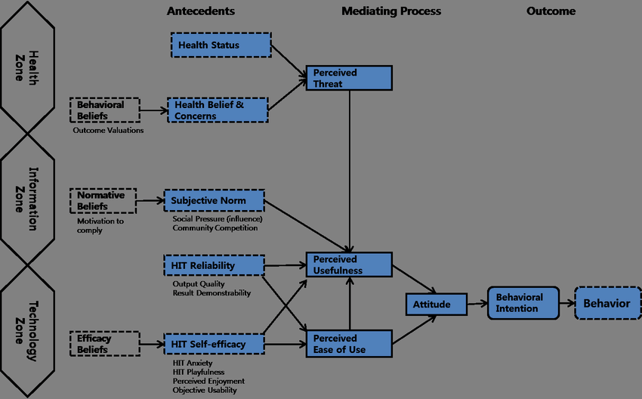

## 2.3 Previous studies

### 2.3.1 FAO promoting health diet

According to the Food and Agriculture Organization of the United Nations (FAO) website (2021), the organization has implemented various solutions to promote good healthy eating in Zambia. The FAO has worked to make dietary guidelines accessible by providing information on healthy eating habits and balanced diets through nutrition education and awareness-raising activities. The organization has also collaborated with the Zambian government to integrate the dietary guidelines into national policies and programs, as well as supporting the development of food-based dietary guidelines and food composition databases.

In addition, the FAO has worked with partners to strengthen the food systems in Zambia, including the promotion of locally produced and diversified foods, as well as improving the availability and affordability of nutritious foods. The organization has also supported the development of food fortification programs to improve the micro-nutrient content of staple foods, and has provided technical assistance to improve the quality and safety of the food supply.

Overall, the FAO's efforts aim to ensure that the people of Zambia have access to safe and nutritious food and are equipped with the knowledge and skills to make healthy food choices.

### 2.3.2 Impact of a new web-based app (e-balance) in promoting healthy lifestyle

The study by Naimark et al. evaluated the impact of a new web-based app (eBalance) in promoting healthy lifestyles. The study was a randomized controlled trial that recruited participants from the community and compared them to a control group who received only an introductory lecture on healthy lifestyles. The app was developed based on current USDA and Israeli Ministry of Health recommendations and provided tools for monitoring diet and physical activity while encouraging healthy choices. Results showed a positive impact of the app on weight, physical activity, nutritional knowledge, and diet quality compared to the control group. Additionally, the frequency of app use was related to a higher success score in maintaining a healthy lifestyle. The study highlights the potential of the app in promoting healthy lifestyles, but larger and longer duration studies are needed for more definitive conclusions.

## 2.4 Research gaps

* Limited research on the dietary habits and preferences of specific demographic groups in Zambia, such as pregnant women, children, or elderly individuals.
* A lack of research on the effectiveness of nutrition education and awareness programs in promoting healthy eating habits in Zambia, particularly in rural or low-income communities.
* Limited research on the cultural and social factors that influence food choices and eating behaviours in Zambia, and how these factors can be addressed to promote healthier diets.
* Insufficient research on the potential impact of climate change on food security and the availability of nutritious foods in Zambia.
* Limited use of web technology to solve medical issues
* Limited research on the use of technology in promoting healthy eating habits and improving nutrition in Zambia, and how best to design and implement digital interventions that are accessible and effective for different populations.

## 2.5 Research variables arising from literature review

* Dietary intake: This variable could include the amount and types of foods consumed by individuals, as well as any nutritional deficiencies that may be present in the population.
* Cultural and social norms: These variables could influence what foods are considered acceptable or desirable to eat, and how meals are prepared and consumed.
* Availability and access to healthy foods: This variable could include the physical availability of healthy foods in Zambia, as well as the affordability and accessibility of these foods to different segments of the population.
* Technology adoption and usage: This variable could include the extent to which technology is currently being used in Zambia to support healthy eating, as well as any barriers to adoption or usage.
* Health outcomes: This variable could include measures of health status or disease prevalence that are related to diet, such as rates of obesity, malnutrition, or chronic diseases.

## 2.6 Conclusion

Based on the reviewed literature, it is evident that promoting healthy eating in Zambia is crucial for improving the health and wellbeing of the population. The Health Information Technology (HIT) Model provides a holistic perspective on how technology can support healthy eating by considering individual characteristics, technology features, and the environment. The FAO has implemented various solutions to promote healthy eating in Zambia, including making dietary guidelines accessible and strengthening the food systems. The study by Naimark et al. demonstrated the potential of a web-based app in promoting healthy lifestyles. However, research gaps exist in understanding the dietary habits of specific demographic groups, the effectiveness of nutrition education programs, the cultural and social factors influencing food choices, the impact of climate change on food security, and the use of technology to promote healthy eating habits.

Overall, the reviewed literature provides a foundation of knowledge and understanding that will inform the design and implementation of the proposed research. By addressing the identified research gaps, the study will contribute to the existing literature on promoting healthy eating in Zambia and provide insights for developing effective and sustainable interventions. The findings of this research will be valuable for policymakers, public health practitioners, and other stakeholders involved in promoting healthy eating in Zambia.

# **3.0 CHAPTER THREE: METHODOLOGY AND DESIGN**

## 3.1 Introduction

Chapter Three outlines the methodology and design employed in this study to address the research questions and achieve the research objectives. The chapter presents a detailed account of the research approach, design, data collection methods, data analysis techniques, and ethical considerations. The rationale behind the chosen methodology and design is discussed, and the strengths and limitations of the approach are also addressed. The chapter is organized into several sections to provide a clear and comprehensive overview of the study's methodology and design. The following sections describe the research approach, design, data collection methods, and data analysis techniques in detail. Additionally, the chapter highlights the measures taken to ensure the study's ethical conduct, including informed consent, confidentiality, and data protection. Overall, this chapter aims to provide readers with a clear understanding of how the research was conducted and how the data was analyzed to address the research questions and achieve the research objectives.

## 3.2 Research Philosophy and approach

In this section, we will outline the research philosophy and approach for our study on Healthy Bites. Due to time constraints, our research approach will not include focus groups or interviews, but instead rely on information from nutritionists and Google questionnaires.

Our research will still follow the Software Development Life Cycle (SDLC) model, which involves several stages, starting with the planning stage. In this stage, we will establish the goals and objectives of our research, and identify the scope of our study. We will review existing literature on the topic, consult with nutrition experts, and use Google questionnaires to gather relevant data.

Next, we will move on to the analysis stage, where we will gather and analyze data related to the nutritional content and quality of food options available to consumers. We will use a variety of data sources, such as nutritional databases and Google questionnaires, to help us gain a better understanding of current eating habits.

The design stage will involve the development of our research framework and methodology, where we will carefully design our study to ensure it is both valid and reliable. We will use appropriate sampling techniques and statistical analysis to ensure the accuracy of our findings.

Once our research methodology is established, we will move on to the development stage, where we will begin collecting and analyzing data. We will use Google questionnaires to gain insight into consumer attitudes and behaviors related to healthy eating.

The testing stage will involve the validation of our research findings and the identification of any potential biases or limitations in our study. We will conduct thorough data analysis to ensure the accuracy and validity of our findings and address any potential issues that may arise.

Finally, in the deployment stage, we will disseminate our research findings to key stakeholders, such as policymakers, healthcare providers, and nutritionists. We will provide recommendations for improving healthy eating habits, and promote the adoption of evidence-based interventions to improve the nutritional status of consumers.

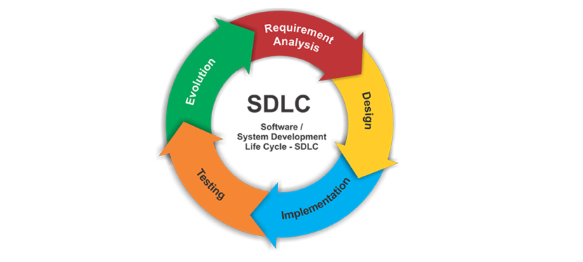Overall, our research philosophy and approach is grounded in the SDLC model, which provides a structured and systematic approach to the study of healthy eating habits, even when faced with time constraints. Through careful planning, analysis, design, development, testing, and deployment, we aim to generate robust and actionable insights that will contribute to the promotion of healthy eating habits and the prevention of diet-related diseases.

## 3.3 Research design

# **REFEENCE**

* Food and Agriculture Organization of the United Nations (FAO). (2021). Food and Dietary Guidelines – Zambia. Retrieved from https://www.fao.org/nutrition/education/food-dietary-guidelines/regions/countries/zambia/en/
* Naimark, J. S., Madar, Z., & Shahar, D. R. (2023). The Impact of a Web-Based App (eBalance) in Promoting Healthy Lifestyles: Randomized Controlled Trial. Journal of Medical Internet Research, [Article]. <https://doi.org/10.2196/jmir.9999>.
* Wakefield, B., Zgibor, J. C., & Kullgren, J. (2016). Health information technology and behavior change: a review of the literature. American Journal of Preventive Medicine, 50(3), 283-294.
* UNICEF. (2021). Zambia Scaling Up Nutrition Newsletter July 2021. Retrieved from <https://www.unicef.org/zambia/media/2406/file/Zambia-scaling-up-nutrition-newsletter-july-2021.pdf>
* National Food and Nutrition Commission. (n.d.). About Us. Retrieved January 25, 2023, from <https://www.nfnc.org.zm/about-us/>
* Simplilearn. (n.d.). What is SDLC (Software Development Life Cycle)? Simplilearn.com. Retrieved January 25, 2023, from https://www.simplilearn.com/tutorials/programming-tutorial/what-is-sdlc
* Grad Coach. (n.d.). What is a Literature Review? Retrieved from https://gradcoach.com/what-is-a-literature-review/